drum

STRONG
hand

BOOK

Hello and Welcome,

Thank you for your interest in participating in our most unique initiative.

We’ve created an all-inclusive, collaborative program that allows people of all ages, wages and stages of health to contribute to and gain a wealth of health knowledge, fortification and satisfaction.

DrumsForCures, Inc. is our 501(c)(3) non-profit charity organization that produces the annual cancer health resource event, DRUMSTRONG™; a multicultural, musical, charity event showcasing available resources that support people with cancer and those who love them.

Rhythm is our delivery system. Our family-friendly events take place globally and we embrace ALL cancer initiatives and populations. We are raising awareness and funds for important cancer initiatives, supporting survivorship and drumming for crazy long periods of time... to BEAT cancer!

As unique as every DRUMSTRONG event is from city to city and country to country, a common thread prevails. DRUMSTRONG embraces the individual spirit of giving and channels the power of community efforts.

We’re using rhythm to help people find focus and solid support in the unsettling ‘roller-coaster’ world of wayward cells.

It’s personal. It’s your rhythm :: your cause. We encourage folks to drum in honor of or in memory of someone and/or to fortify themselves. People will raise funds for the cancer initiative of their choice. The DRUMSTRONG experience impacts individuals in an inimitable way and will be interpreted and seasoned by each participant. We invite everyone to express themselves rhythmically, regardless of experience and focus on BEATing cancer.

Through our efforts we've been introduced to some amazing folks and facilities; in the rhythm world and in the cancer health world. We've also fashioned some creative ways to engage many in a most memorable charity activity and help support a lot of folks.

The drumSTRONG handBOOK will help you understand the basic needs and tools to organize your own DRUMSTRONG event and personalize it. We invite you to add ‘spice’ and make it your own.

Wishing you good health,
Scott

Scott L. Swimmer
DrumsForCures, Inc. Founder and President scott@drumstrong.org
725 Providence Rd. suite #210 Charlotte, NC 28207


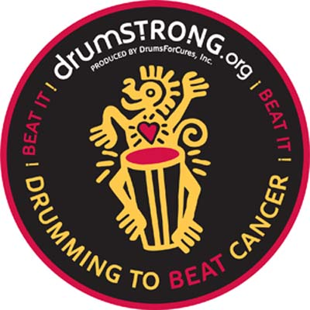

There are several potential ‘levels’ of participation ::

The Groove :: Your Rhythm :: Your Cause

Here are some directives ::

- Procure a Venue :: (Coffee House, Yoga Center, Religious Institution Social Hall, City or Natural Park, Back Yard, Hospital or Clinic, Skating Rink, Music Hall, Club, etc.). Our Main Event is rain or SHINE! (and we’re in the Meadows with tents). We suggest covered or interior space. Try to get space donated or at least discounted. Be aware that you may need Permissions (permits, licensing, insurance, ordinances).

- Date, Time and Duration :: DRUMSTRONG is the third weekend in May. Pick a time that coincides with our Main Event in Charlotte, North Carolina, Eastern Standard Time Zone so we can all play together. See www.drumstrong.org EVENTS. We typically start @ 12:30 pm Saturday afternoon and play for our consecutive designated hours.
Some are 2 hr non-stop events, some are 10 hrs+. Also, many set up simple webcast with a laptop and video cam to webcast their event to us and the rest of the global events.

This gives cities all over the world a wide window of opportunity to jump in and play together. Decide exactly how long y’all will drum (non-stop). Once rhythm starts, the ‘HeartBeat’ drum must continue for the duration. If it’s crazy long, people can come and go as they please. People can ‘spell’ each other, arrange Team schedules to always be represented in the Circle, so the rhythm will be continuous till the designated finish. You always need a minimum of three {3} drummers to qualify as a DrumCircle.

- Choose your Charity :: Must be a non-profit organization. Some options include :: Local or National cancer organization(s) or chapter of a cancer society, Hospitals/Clinics, Hospice, Camp, etc. or defer to one of our established initiatives. Please concur with scott@drumstrong.org

- Media :: Notify Community :: Distribute Handouts, Posters, use Newspapers, Weeklys, Mags, Radio, TV, FaceBook, Twitter, etc. Notify the Charity that you wish to support and ask them to network and to inform their in-house staff, families and patients to participate in raising funds, and drumming. Familiarize yourself with our mission and projects so you can represent our mission and projects. (See the Sample DRUMSTRONG L.A. Tools below and customize) Or ask scott@drumstrong.org

- Find Sponsorship :: Encourage your community to find creative ways to support the cancer initiative of your choice. A suggested donation of $ … is requested. Our featured charity is … Raise ‘per hour drumming’ sponsorships, ask friends and families to donate to the initiative of choice (through DrumsForCures – see items d) & e) below), encourage employers to sponsor and/or match funds, engage service-oriented clubs (Rotary, Kiwanis, etc.), music stores, restaurants/clubs, coffee shops (see Teams on website http://drumstrong.org/register.htm).
- Registration/Waiver Form should be signed by all participants (see below). You may want a (responsible) volunteer to take donations/pledges on site. Encourage folks to visit your page on the drumstrong.org website and pre-register for your event.

- The Facilitator will be responsible for maintaining the rhythmical ‘safety’ of the Circle and continuance of the Non-Stop Beat. They may need assistance (depending on size and duration) and they should be aware that other Facilitators in other Cities holding simultaneous DRUMSTRONG Circles may want to “Co-Facilitate’ with them from wherever they are. We encourage Global Drumming in real-time! Simple volume up/down, rumbles, sculpting percussion families (shakers, blocks, metal) but NO Total Stop-Cuts (must keep HeartBeat Drum or low-end drums going at all times). Facilitators may initiate ‘games & activities’, encourage dancing & hooping, kids’ participation and/or whatever they feel serves the Circle. They will also determine if they want to make their own instruments available. We encourage folks to bring their own or you may want to rent or sell instruments with proceeds or percentage thereof going to the cause.

- Intention :: Periodically during your DRUMSTRONG event, the Organizer/Facilitator will quiet the Circle and remind folks to drum with focused intention; hold someone in their Heart and drum in Honor of or in Memory of someone or for their own fortification.

- All DRUMSTRONG events must be sanctioned by DrumsForCures, Inc. and all funds raised must be delivered to and disbursed by DrumsForCures, Inc. We are the 501(c)(3) non-profit charity organization that will qualify donations as tax deductible. All expenses will be paid and charity disbursements made from our account. Funds raised will be donated to the charity(s) for which your group chooses, and in your group’s name. Expenses incurred by you and/or DrumsForCures, Inc. for your event and a percentage of the amount raised may be deducted from the total raised to be utilized in our outreach programs (see “Some Facts” section ‘f’ below).

9a) So that All parties are Comfortable and Happy about the collaborative efforts manifesting to benefit the health of our communities, be clear that we are offering a fun, memorable platform for the affiliated organizations (hospitals, clinics, camps, cancer societies, etc.) with zero expense to them. There is great (global) exposure and fund-raising opportunities through a joyfilled, fortifying event that benefits many, creates beautiful memories while sharing experiences and intentions...

9b) It is important that the quality and integrity of our mission be upheld. Please request site inspection or confirmation of safety, lighting, sanitary facilities and climate protection, etc. and request any banner representation from us and your sponsors and benefactors to enhance the atmosphere and remind folks why they are drumming.

-----------------------------

The Simple Beat ::

You may have an existing rhythm community that gathers regularly. Make DRUMSTRONG the center of focus for that gathering. Suggest that drummers donate a token amount to participate and/or encourage them to find ‘per hour’ sponsorship for the event.

Pick the cancer initiative that the event will benefit (local, national or let us help direct your efforts).

Provide armless chairs and form a comfortable circle.

Recite the DRUMSTRONG ‘Creed’ (see below).
Start!

During your rhythm event, the Organizer/Facilitator will remind folks to drum with focused intention; in honor of or in memory of someone or for the their own fortification.

Drum Non-Stop for the designated duration. Take pictures/video.

------------------------------

The Full-Tilt Boogie ::

Invite the local medical community (Traditional and Integrative), cancer societies and private practices to exhibit. They will have an opportunity to introduce the community to their missions and methods, engage their staff, families & patients to participate (and allow them to raise funds for their own organization) and DRUM!

Provide vendors space to sell food, snacks, drinks, art and/or percussion instruments.

Invite celebrity talent to join in and endorse our causes.

Invite Media and promote (see #3 below)

Take pictures, video, and for those interested, webcast your DRUMSTRONG event through our website up-link so we can all play together (see ‘Global Webcast’ below).

Provide armless chairs and form a comfortable circle.

Recite the DRUMSTRONG ‘Creed’ (see below).
Start!

Drum Non-Stop for the designated duration. If it’s crazy long, people can come and go as they please as long as there is always at least three peeps and a Beat!

Encourage folks to bring their own rhythm instrument of choice but you may want to provide percussion. As simple as recycled Water Bottle Shakers (maybe have a volunteer staff a ‘Shaker Maker Station for kids) or request 5 Gallon Buckets from your local Home Depot/Lowes, or invite your local drum-maker or retailer to sale items (% of proceeds to the cause)…

-----------------------------------

Make it your own :: Any elements or combinations of the above.

Support ::

We will provide you with templates for sponsorship solicitation, Logo and info to use in your media package, handout & poster templates (see below), DRUMSTRONG website inclusion and links for your individual Team Fundraising Campaign and webcast support (if you choose to video).

There is a plethora of info in place on the www.drumstrong.org website.

We can send you 2’ wide x 3’ tall Banners for you to display or have custom Banners made with DRUMSTRONG Logo & branding and will deduct costs and shipping from proceeds raised.

Expenses :: Keep ‘em at a minimum and encourage community “in-kind” services. We love to promote those who generously support our efforts. Displaying their Banners, web-presence, and on site presence is offered in certain venues.

If on a larger scale, you may need Tents, Tables (displays, vendors), Chairs, Lights, Power (or generator). If you need to rent a space, print materials, purchase product or pay artists, contact scott@drumstrong.org to gain approval. We will deduct your costs from the funds your DRUMSTRONG event generates, pay the approved expenses and donate the balance to your chosen initiative.

Safety :: Ear protection is a good thing. Water (for longer events) is essential. Briefing on Hand and Drum safety (rings off, simple warm-up/stretch, basic hand drum technique, no sticks on certain skins) will be the responsibility of Organizer/Facilitator.

Use your discretion with regard to your population’s comfort. You may have folks going through physical and/or emotional challenges, especially if they’re dealing with a cancer experience. Have an assistant monitoring for needs and don’t hesitate to engage.

Maintain and Service the Circle. Keep a safe ‘isle’ access or several. Keep the area in front of the webcast camera clear so the rest of the world can see and participate with you.

Maybe provide volunteer ‘kid supervision’ but don’t assume responsibility for other’s children. See waiver.

If outdoors or in a larger public facility, assign a volunteer to corral instruments that aren’t being played so they don’t ‘walk away’.

Assign a qualified ‘First Aid’ attendant.

Community Service Opportunities :: Depending on the scale of your DRUMSTRONG experience, you may want extra hands on board for assistance other than drumming (set-up, drum distribution & care, clean-up, etc.). Find Volunteers from Schools (Clubs, Athletic Teams, Fraternities/Sororities), Scout Troops, Religious Youth Groups and Survivors. You’ll want a ‘Street Team’ to help distribute posters. Volunteer groups will also avail fundraising potential. (see http://drumstrong.org/register.htm for options).

Exhibitors/Vendors :: Depending on the scale of your DRUMSTRONG experience, you may invite Hospitals/Clinics, Private practices (Urologists, Dermatologists, OBGYN, Radiologists, Camps, etc.), Integrative/Complimentary health entities (massage, Reike, dietary consultation, etc.), Health Mags and products (food, beverage, instruments) to display and vend. Some, especially those who stand to profit from exhibiting, may pay a fee or percentage of sales.

Global Webcast ::
A simple laptop with video cam (or iSight) and the DRUMSTRONG web up-link will send your DrumCircle worldwide. If available, find a volunteer with a video camera and cable to ‘film’ the event. We will assign you your individual URL and include your event through the www.drumstrong.org website.

Be sure the Facilitator can be seen on camera and that they can see the monitor. If available, use a large TV monitor or a screen to project the Global participation.

Merchandise :: We have very cool DRUMSTRONG tee-shirts, Drums, Sound Shapes, Egg Shakers, DrumSticks, Wrist Bands and Logo Decals (for cars, drums, etc.) available for purchase and to make available for you to sell at your event.

Some Facts :: www.drumstrong.org
a) DrumsForCures produces DRUMSTRONG, the family friendly, multicultural cancer health festival; raising awareness and funds for important cancer initiatives and drumming for crazy long periods of time to BEAT cancer.
b) It is the world's longest facilitated rhythm event (Drum-A-Thon).
c) Rhythm is our delivery system. We embrace ALL cancer initiatives, invite them and other cancer health resources to display @ our events. Traditional medical and integrative health entities, along with private practices and cancer societies display during our weekend-long event.
d) We’re an all-volunteer 501(c)(3) with minimum overhead. After expenses, 100% of funds raised are donated to local and global cancer initiatives.
e) At certain levels of participation, you choose the charity and your donation will be made in your name through DrumsForCures. This makes participant's efforts even more personal, boosts our ‘presence’ and amplifies our potential assistance through affiliations.
f) DRUMSTRONG events also provide funds for our PPPulse (Pediatric Percussion Programs) and Cancer Health Integration and Education programs (see CHI&E on the drumstrong.org website).
g) We avail community service hours to students and institutions for volunteer services encouraging many young people to engage in their first memorable, charitable behavior with team participation (we are a most unique initiative).
h) We encourage individuals and Teams to raise per hour drumming sponsorships and to drum in honor of or in memory of someone or for their own fortification through an activity that all can participate in regardless of "wage, age or stage of health".
i) Donations made through DrumsForCures 'earmarked' for certain organizations will be matched $ for $ (though we encourage support for all local initiatives and provide exhibit space for all) (see website for charities).
j) Celebrity artists share their heart and talent and endorse our projects.
k) Our facilitated rhythm-driven events take place globally. Cities all over the world join together to play with us every May.
l) If the Main Event dates don’t work for you and/or you prefer to hold a satellite DRUMSTRONG event, let’s talk. DRUMSTRONG 2011 is May 21 & 22
Event Waiver :: You may want to customize this. The personal info will also serve as our contact mailing list for future events. Make sure folks print their name & email clearly or ask a volunteer to enter the participants’ names and emails onto a laptop.

DrumsForCures, Inc. presents DRUMSTRONG™. Welcome! Here you will gain insight to sound cancer health resources, drum alongside celebrity artists and friends, break a world record, support cancer survivorship and raise funds for a great cause in the process. We are happy to have you join us!

REGISTRATION :: CONTRACT :: ENTRANT WAIVER & FUND-RAISING AGREEMENT

Please accept my entry into the DrumsForCures :: DRUMSTRONG™ event (hereinafter called "Event") that directs funds to local and global cancer initiatives. My acceptance as noted below will confirm that I am 18 years or older and have read and understand the following.

I assume all responsibility for injuries and damages that may result as an active entrant in this Event.

As a condition of my entry, I hereby for myself, my heirs, executors and administrators, release, exempt and discharge DrumsForCures, Inc., Event sponsors, Event subcontractors, Event staff, Event volunteers, and cities/towns/municipalities in which the Event is held and properties on which Event festivities will take place from all claims, damages and courses of action, present or future, whether they result from, arise out of or are incident to my participation in the Event. I also grant permission for the use of my name, recorded voice or instrument and/or video or photographed images in press releases, kits, media broadcasts or any other public relations account of the Event. By signing below, I agree to the terms outlined herein and the ‘Rules’ of the Event (as stated here and on site).

THE RULES ::
Please respect each other and this property :: Enjoy this time and place :: DRUM STRONG
No Smoking on the property. (There is a designated smoking area just outside the main entrance.)
No Alcohol or Illegal Substances. They WILL be confiscated. Violators will be asked to leave without refund.
PARK only in designated areas
No open, unsanctioned fires or fireworks (cook stoves are OK).
No glass containers
No weapons
No Pets please
* KEEP IT CLEAN :: Place Trash in Receptacles :: recycle and PLEASE, KEEP IT CLEAN*
PLEASE PRINT CLEARLY

Name :: _________________________________________________________Date :: ___________

Email :: __________________________________________________________________________
Signature :: _________________________________Guardian :: ____________________________

DRUMSTRONG™ ‘Creed’

“Drum to rekindle the fire of survivorship in you.

Drum in honor of or in memory of or just out of the goodness of your hearts.

Drum with hopes of opening the eyes and hearts of more people to amplify efforts to find cures.

Drum to respect and represent all the fighters and survivors who share this history.

DRUM LONG, DRUM STRONG!”

::::::::::::::::::::::::::::::::::::::::::::::::::::

DRUMSTRONG 2011 is May 21 & 22
www.drumstrong.org

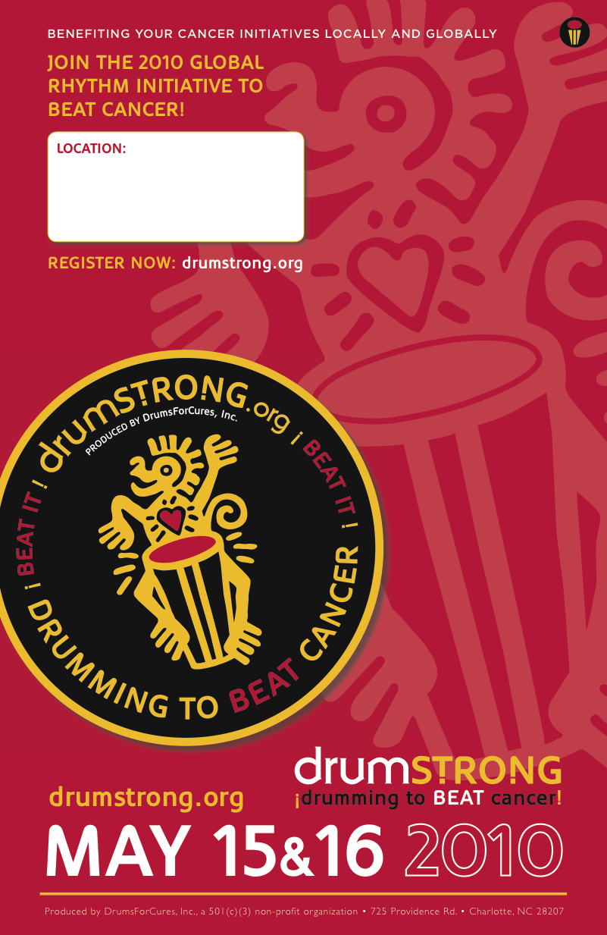
TOOLS :: (Customize)

How (and Why) DRUMSTRONG Works ::

Our mission is to make important cancer health resources and funds available to support survivorship, educate and bring us closer to cures. We do it through rhythm :: the simplest (fun!) form of communication and something every body can do.

Support DRUMSTRONG by asking friends and family to sponsor your ‘per hour’ (or lump sum) efforts as you beat your drum to BEAT cancer. Go to http://www.drumstrong.org/event.htm and download your Individual or Team* DRUMSTRONG sign-up sheet.

*TEAMS will represent schools, clubs, corporate and religious institutions, and are encouraged to solicit sponsorships and engage in ‘friendly competition’ for largest Team, most $ raised, and who can ‘represent’ with the most team members in the Drum Circle the entire time.

We encourage Individuals to raise a minimum donation of $25., Families $50. and Teams $100. to participate. Regardless of donation, we want you to come out and play!

To learn more about DRUMSTRONG’s rhythmical global impact and meet the charities, please visit http://www.drumstrong.org

Below, please find ::

SAMPLE Letter for your sponsors ::
SAMPLE Flier ::
SAMPLE Sign-up Sheet ::

The Flier and Sign-up are written as an Example for DRUMSTRONG L.A. You can create a generic or specific form for your individual city and/or beneficiary (please customize and personalize as you see fit and is necessary).

Please use these FORMS to help you to inform and encourage your sponsors to participate ::
DrumsForCures presents DRUMSTRONG™ :: rhythm : from : the : heart

Hello,

Will you help me drum up support for the millions of people whose lives are affected by cancer? I am participating in an extraordinary event called DRUMSTRONG™.

On May 21, 2011, I will join a multitude of others worldwide, drumming non-stop to raise cancer awareness and funds for education, survivorship support and for noteworthy charities to BEAT cancer.

Please help me meet my fundraising goal by making a tax-deductible contribution to "DrumsForCures". You can sponsor me for my ‘per hour’ efforts or a lump sum.

Please add your name, e-mail, and the amount you’d like to contribute on my sign-up sheet to help me BEAT cancer.

Make your check payable to DrumsForCures and mail to:
DrumsForCures, Inc.
725 Providence Rd. #210
Charlotte, NC 28207

Or, I will be happy to deliver to the representatives at the event.

Please note my name as your drummer on the check!

DrumsForCures, Inc., producer of DRUMSTRONG ™ is a 501(c)(3) nonprofit charity organization. Your contribution is tax deductible to the extent of the law.

Please see www.drumstrong.org for details.

On behalf of those whose lives are affected by cancer, I thank you for your support.
With your donation, we are helping to make a sound impression on the health of our community.

The power is in your hands!

Sincerely,
DRUMSTRONG L.A. :: rhythm : from : the : heart
Come Drum with us to BEAT cancer!
DrumsForCures presents the rhythm-driven cancer health festival, DRUMSTRONG L.A.
:: a 2 hour, non-stop Drum Circle
Sponsored by REMO & Village Music Circles

featuring resources addressing cancer concerns and drumming to
BEAT cancer!
Join celebrity guest artists sharing their rhythmical talents
raising awareness and funds to support cancer education and survivorship.
Plenty of drums will be provided, or bring your own.
Tell Everybody! Family & Friends welcomed.
We will drum with cities around the World to BEAT cancer!

May 21, 2011 :: 1:00 pm - 3:00 pm
REMO Recreational Music Center :: 7308 Coldwater Canyon, North Hollywood, 91605
Benefiting Simms/Mann Center for Integrative Oncology, Children’s Hospital L.A. and LiveStrong

Show your support :: Sign up now. Download the easy to use donation form at www.drumstrong.org
A most unique, multicultural, facilitated DrumCircle :: experience of a lifetime!

DrumsForCures presents DRUMSTRONG L.A.
cancer health resources and survivorship support DrumCircle
May 21, 2011 :: 1:00 pm - 3:00 pm :: REMO Recreational Music Center
Join in :: come drum, learn and ¡BEAT cancer!

:: your drummer :: _____________________________________

name :: email :: $ pledge $
Please make checks payable to DrumsForCures
THANK YOU for your support – DrumsForCures, Inc. is a 501(c)(3) ¡the power is in YOUR hands!
www.drumstrong.org

